Directions: The goal of the following problems is to help challenge and deepen your understanding of the current topic. Don’t assume that you will know how to answer each and every question. You will work with at least two other students in the class to try and find solutions and write arguments for each of the following questions. Be sure that you question your classmates’ reasoning. If you don’t understand how they are getting something you should ASK THEM TO EXPLAIN! Being able to defend your reasoning is important and so you are actually helping them by asking them to explain.

- Consider the function on the interval .

- Estimate the area under the curve on using a left endpoint Reimann sum with 4 rectangles.
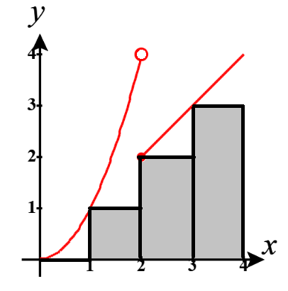

We see that .
The picture at the right shows us the shape of each rectangle we have.

We calculate that .

- Estimate the area under the curve on using a right endpoint Reimann sum with 2 rectangles.
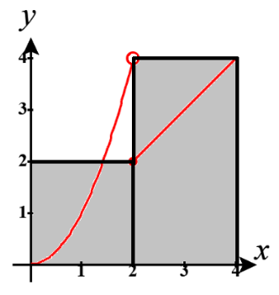

We see that .
The picture at the right shows us the shape of each rectangle we have.

We calculate that .

- Estimate the area under the curve on using a midpoint Reimann sum with 2 rectangles.
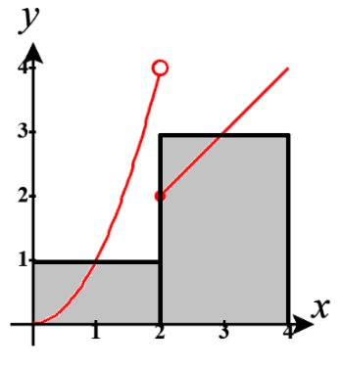
We see that .
The picture at the right shows us the shape of each rectangle we have.

We calculate that .

- Suppose that the speed of a runner was always increasing for . Use the data on the runner’s speed to give an upper and lower estimate on the distance travelled from 10 seconds to 30 seconds.
time (seconds) | 10 | 12 | 20 | 24 | 30
speed (ft/sec) | 7 | 8 | 9 | 9.5 | 10

We can create the following graphs to guide our thinking. (The curves connecting the points loosely describes the runner’s speed but is just made up and not derived from anywhere.)
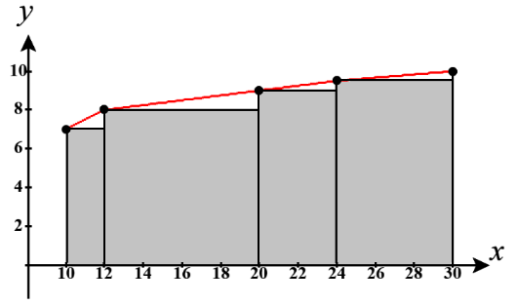
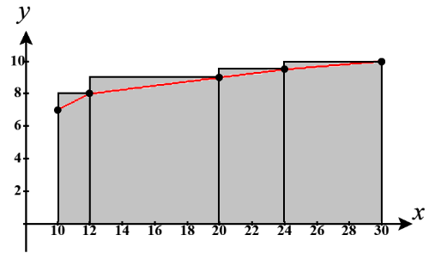

We see that using a left endpoint estimation that .
Using a right endpoint estimation we have .

Therefore, we can confidently say that the distance travelled by the runner is somewhere between

- Consider the function over the interval .
- Show that is decreasing over .

We calculate that .
Note that when and
is never undefined.
We then create the following number line and use test points to determine where f is increasing and decreasing.
2
$$-$$
$$+$$

Clearly, is decreasing on .

- Suppose we attempt to estimate the area between and the x-axis on . Will the sum created by using a Left Reimann sum be an over or underestimate? Will the sum created by using a Right Reimann sum be an over or underestimate? Explain.
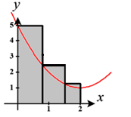
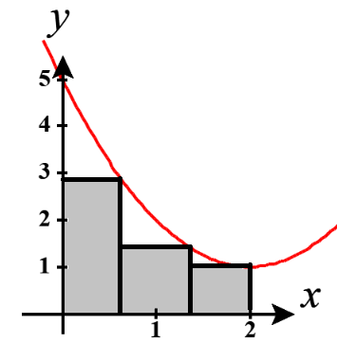

If we draw a picture of each scenario here, we see that the left Reimann sum will result in an overestimation of the area while a right Reimann sum will result in an underestimation of the area.



- Suppose you split into n subintervals of equal length (). Graphically demonstrate how the error from or is less than .


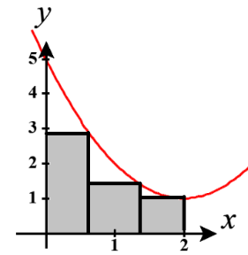
We see from the picture at the right that represents the area of a rectangle (shown in blue at the right). If we then draw spaces which represent space where over/underestimation occurs (shown in red at the right) we can see that in each case the total red space is less than the total blue space. (If this is difficult to see imagine sliding each red space to the left so that they touch the y-axis and are lined up much like the blue rectangles in the pictures above.)
If we let E represent the error of either or then we clearly have that .

- Use what you showed in part (c) to explain what happens to the error from either or as we divide the interval into more subintervals? How do and compare as ?

As we divide up into more subintervals we will have E being less than smaller and smaller values (since gets smaller as n gets larger). We then can guess that as it is the case that for both and .

We can directly show this by saying that and since , then, by the Squeeze Theorem, it must be the case that .

This implies that the error of these estimations (using left or right endpoints) will have an error that approaches 0 as . This means that the approximations become the actual area as !

- Consider the function .
- Estimate the area under this curve from using right endpoints with .

- Create a formula to estimate the area under the curve with rectangles.

Width of rectangles:

Right endpoints:

Height of rectangles:

Therefore,
- What could you add to the formula above for the formula to represent the total area of the region?

Based on what we saw in #3(d) we know that if we were to let n approach infinity then the approximation we have in part (b) would represent the actual area under the curve on .

Therefore, we have

